Single run:

1. Factor -- x² – x – 6

(x – 3)(x + 2)

2. Simplify -- 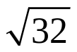

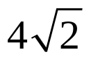

3. Write the expression as a complex number in standard form:
(5 + 3i) + (2 + 4i)
7 + 7i
4. Write the expression as a complex number in standard form:
(8 – 5i) – (1 + i)
7 – 6i
5. Write the expression as a complex number in standard form:
(1 + 3i)(3 – 4i)
15 + 5i

6. Write the expression as a complex number in standard form:
-4i(3 – 7i)

-28 – 12i

Double run:
1. Solve -- x² = 36

x = 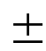6

2. Solve by factoring -- x² – 2x – 3 = 0

x = 3, x = -1

3. Solve by using the square roots method -- 5x² – 180 = 0

x = 6

4. Write the expression as a complex number in standard form: 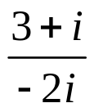
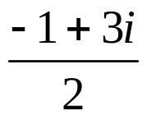
5. Find the discriminant: x² + 6x + 9 = 0

0

Triple run:

1. Solve by factoring: 2x² – 4x – 30 = 0

x = -3, x = 5

2. Solve the equation by finding the square roots: x² + 1 = 3x² – 13

x = 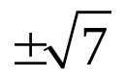

3. Solve the equation: x² + 3 = -24
x = 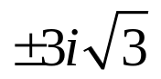

4. Solve the equation using the quadratic formula: -x² + 3x – 5 = 0
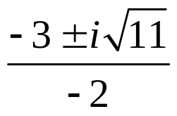
5. Find the value of x, knowing the area is 49 square feet:
x
x – 7
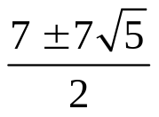

Home run:

1. Factor the equation: 4x² + 11x + 13
not factorable
2. Solve by using the square roots method: (x + 1)² – 16 = 0
x = 7, x = -9
3. Write the expression as a complex number in standard form: 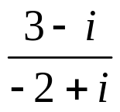
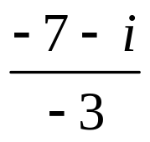
4. Solve the equation: -4(x – 1)² + 3 = 6
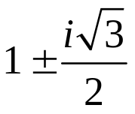
5. Solve the equation using the quadratic formula: 4x² – 9x + 2 = 0
x = 2, x = 
6. Find what is needed: The equation g = 0.23m² gives the gross profit (in dollars) of the minutes worked. How many minutes are worked if the gross profit is $20,500? Round your answer to one decimal place.
298.5 minutes

